The College Essay Guy (CEG) Guide
About
- In 2011, Ethan Sawyer created a free college essay resource blog. The goal: bring more ease, joy, and purpose to the college admission process.

- Over the next few years, Ethan begins teaching pay-what-you-can courses and training up a team of essay specialists to work with students individually.

- Today, CEG offers a broad range of online courses for students and counselors, plus in-person workshops, an essay review platform, and 1-on-1 college counseling and essay coaching.

Check out College Essay Guy’s Guide on how to write the Personal Statement.
- Non- video Guide: How to Write a Personal Statement [2023]
- Video Guide: How to Write a Personal Statement [2023]
NOTE:
The Live Video Sessions Run from June 8th - June 29th.
The Video Guide is NOT FREE however you can submit a Pay What You Can Request to CEG and join the Live Sessions for FREE.
- Personal Statement Examples from CEG
- 12 Personal Statement Examples + Why They Worked Analysis
- 27 Outstanding College Essay Examples From Top Universities 2022
- Watch video Recommendations from me!
- Tips for writing an African Student’s PS
- How to Write an Awesome College Essay
- How to hook a Reader on your Essay
- Trivial Pursuit Essay
- Tips to help your essay stand out!
- Culture Essay
Still Need More Help?
Take Courses on:
- How to Write a Personal Statement: A Live Video Course for Students (Live Video Sessions Running from June 8th - June 29th) [2023]
- How to Write the College Application + Supplemental Essays: A Live Video Course for Students
- How to Build a Great College List: Student & Families Edition

Additional Essay Review Support by CEG
- Get your Essay Reviewed for free

FAQs:
- What types of essays are eligible for review?
- The 650-word personal statement for the Common Application
- The 550-word main essay for the Coalition Application
- Any of the 350-word University of California Personal Insight Questions (UC PIQs)
- Any additional or supplemental essays that are a part of the application for specific universities (ex: MIT / Brown / Stanford / UVA / USC)
- Essays for the Apply Texas, New York, or other state school systems
- Essays for the UCAS application in the UK
- What does the essay review typically look like?

The review has TWO major sections
SECTION 1:
- Heads Up Section:
[Your Assigned Coach will brief you on the CYOA Tool]

- Overall Feedback
Thanks for sharing your story with me. You here have a story that reflects on your experiences going from a life of wealth to a life of less-wealth. Below, I’ll give you a big-picture overview of my thoughts, and then go into more detail with my in-line comments. Read on for my thoughts about how to move forward with revising.

- Feedback on Topic / Content.
At College Essay Guy, we tend to think of essays as being either Montages or Narratives. A Montage uses a guiding idea to tie together a series of different examples, and a Narrative tells the story of a single (or in some cases a couple) of challenges the writer experienced.
3. Feedback on Structure / Flow.
[Coaches’ feedback]
4. Next Steps
[Coaches’ instructions]
SECTION 2
B. Actual edits
See the image below…
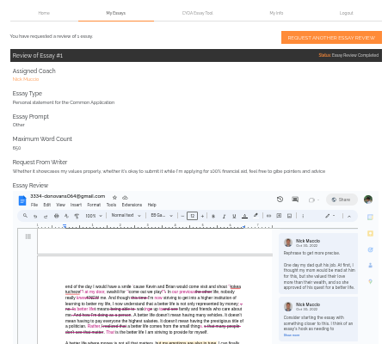

~ THE END ~

